ORG 0000H

MOV TMOD,#01H

HERE:MOV TL0,#66H

MOV TH0,#0FCH

CPL P1.2

ACALL DELAY

SJMP HERE

DELAY:SETB TR0

AGAIN:JNB TF0,AGAIN

CLR TF0

CLR TR0

RET

END

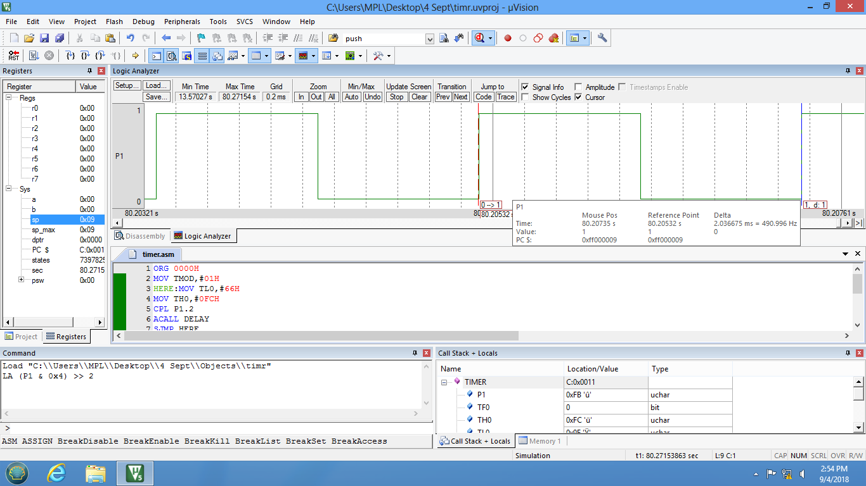

ORG 0000H

MOV TMOD,#20H

MOV TH0,#26

HERE:MOV R5,#2

ACALL DELAY

CPL P2.2

SJMP HERE

DELAY:SETB TR1

AGAIN:JNB TF1,AGAIN

CLR TF1

CLR TR1

DJNZ R5,DELAY

RET

END

